
Class News: Friday 17th January 2025

Elder Class: In English, students have been working towards their functional skills examinations. This has included looking at formal and informal language and writing an email in a formal tone.
In maths, students are completing a topic on shape, space and measure. They have looked at time as well as 2D and 3D shapes and are beginning to describe properties of these.

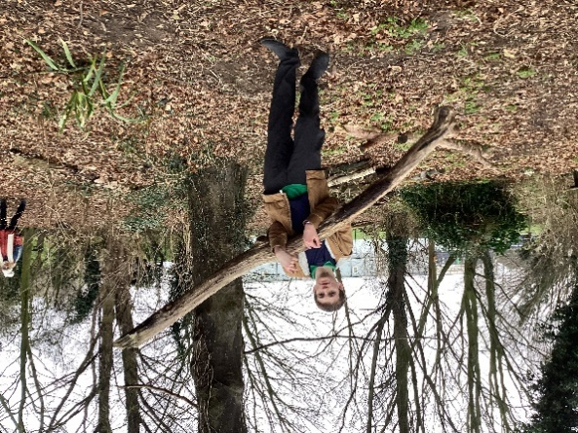
In outdoor adventure
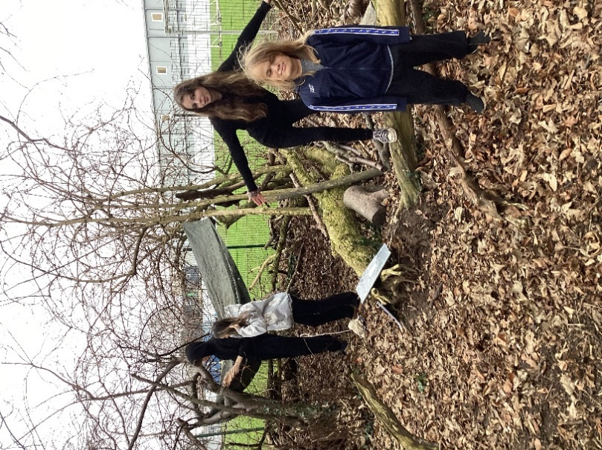
this week, students have
been building shelters.

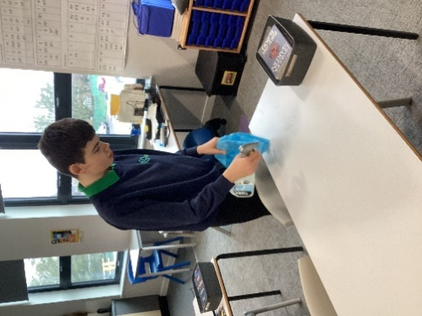
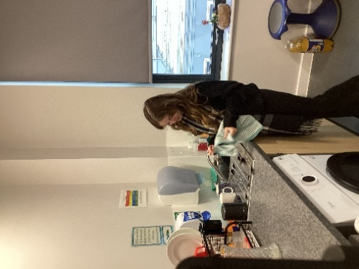
Students in work placed learning have visited McDonalds this week to look at different careers available and are looking forward to visits to St Pauls, Ascoughee Hall and the fire station in the next few weeks. In life skills, students have been tidying and cleaning and students at Springfields continue to work hard.

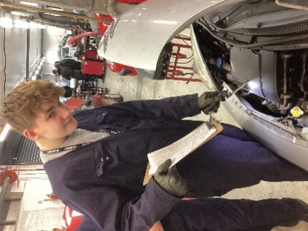
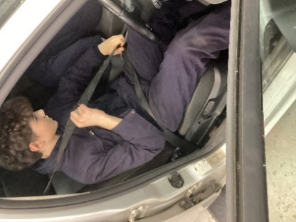
Students continue to enjoy their visits to
college on a Friday and are becoming
used to this routine and are learning new skills.

