**Class News: Friday 6th December 2024**

**Mangos Class:** This term, Mangos class have been Festival ready!

During our STaRs sessions, we have engaged with songs and actions based on the festivals; Glastonbury and Pride!

In Explore and Discover sessions, we have engaged with the festivals of St Patrick’s Day🍀 and Diwali 🪔 and have engaged with creating a class rangoli table cover.

Our Sensology sessions have been based on the celebration, Black History Month. Rosa Parks has been a favoured person to explore; listening to the wheels on the bus, rolling wheels around the classroom and beeping the horn, making all jump from their seats!

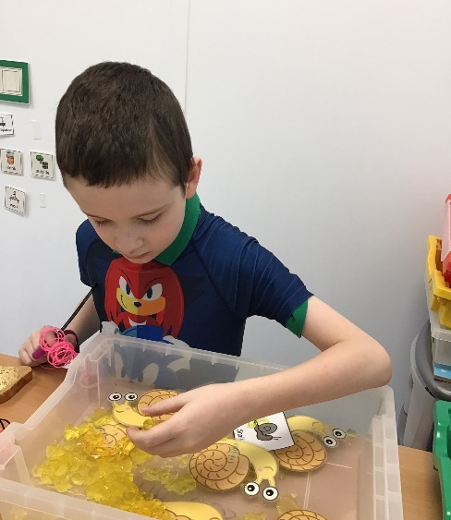It’s been a term to celebrate! Well done Mangos class 🥭

**Plums** **Class**: We’ve had a very busy time, especially as we build up to Christmas, although the rest of the term has also been full on! So much learning and so much fun!

Highlights of the last few weeks include International French Day; here we explored French food, customs, dance and culture. The croissants went down very well which we enjoyed with a traditional glass of wine (or was that blackcurrant?)

Plums class contributed to Springview’s fund raising efforts for Children in Need where we counted up our laps as we went the extra mile and completed a total of 123 times around the circuit! We talked about why we take part in these events and what it means to raise money for charity and to support those around us.

We had our annual visit to a local church recently to help to decorate a Christmas tree for their festival. We had a wide range of wonderful decorations made by the classes at Springview. Everyone spent time exploring, asking questions and enjoying looking at all of the other trees on display. It was a special time and some took the opportunity to sit quietly as all of the pupils showed great respect and sensitivity.

This was a lovely start to the Christmas season as we look forward to all of the upcoming celebrations. We’d all like to wish you a very Happy Christmas and to thank you for your support.

Warm wishes from Plums class, Elaine, Jayne and Abi 😊

**Strawberries Class**:

Strawberries class thoroughly enjoyed Tabletop Cricket brought to us by the Charity Cricket &Countryside Trust. Max, who led the session was great involving all the students, teaching them new skills, and making us all laugh. We are looking forward to more sessions this term! 😊

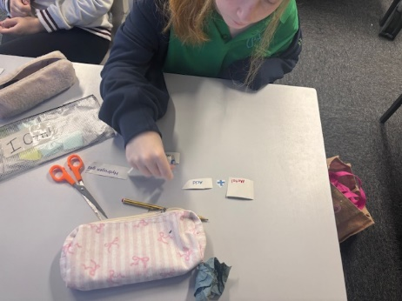**Lime class**: have been super busy – as always!

In English lessons we have been finishing off our book “Holes” by Louis Sachar and are so close to tying all the clues of the story together!

In Maths, we have been working on the 3s, 6s, 9s, and 7 times tables.

In our lessons we have been doing lots of practicing, written work, interactive games, and “enjoying” Miss Hebblewhite singing along to the YouTube videos to memorise our times tables.

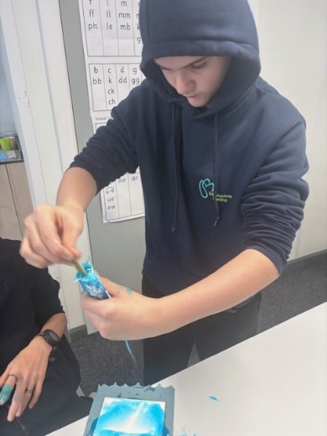In Science, we have just finished off the Chemistry in Our World topic with an exam, just in time for Christmas! For our Year 9 pupils, this is their first formal exam at Tulip Academy and they should be so proud of themselves for working so hard 😊

Here are some pictures of our Forest School lesson this week where we celebrated National Tree Dressing day as part of the Green School Award.

You can also see our recent Target lesson on how our words affect others and can’t be taken back, with some very messy toothpaste!

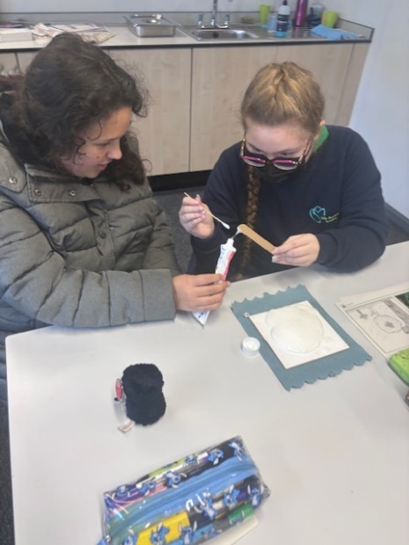A great end to term – Merry Christmas!

