**Class News: Friday 13th December 2024**

**Oak Class:** Oak class enjoyed a visit to Ascoughfee Hall War Memorial gardens to further develop their understanding of Remembrance Day and how war can impact the lives of lots of different people.

This term in English we have explored poetry, we have thoroughly enjoyed listening to different poems, identifying beats, using drums to tap out rhythms in poems and songs.

We have also enjoyed learning about different celebrations as well as exploring light and darkness during our stem work.

The Oak Class have continued enjoy their cookery lessons this term making by pizzas and garlic bread.

**Sycamore Class:** Sycamore class have been busy so far this term. Recently, all year 11 pupils attended ‘the happening’, a knife crime workshop held at Sleaford police station. Pupils were taken through an old part of the police station that had been converted into this workshop, where they took part in various activities, such as CPR and understanding the facts and figures of knife crime. Pupils thoroughly enjoyed this.

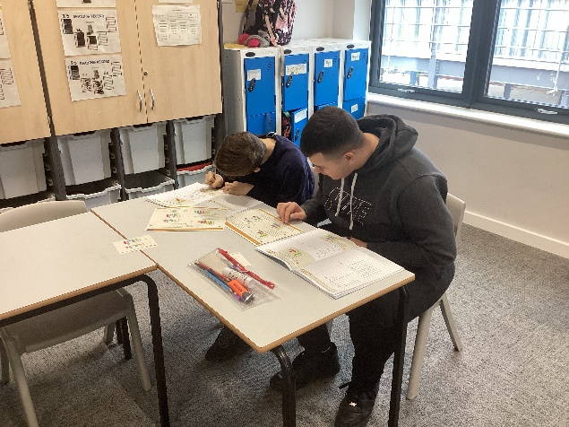Pupils have continued to work super hard in their lessons. They have been focusing on handling data within Maths, interpreting data from different charts, and comparing data.

In PE we have been taking part in cricket with Max. Pupils have loved learning the sport, and the cold hasn’t stopped them!

**Beech Class:** This month Beech class have been very busy entrepreneurs, creating and selling items that they have produced in their Enterprise lessons.

They have created some amazing pieces including,

A story book adventure of an oddball superhero called “Kirkstall man” and another book, produced by a small group, entitled “The multiverse of madness!!”

They have also produced Kirkstall man keyrings and, probably the biggest seller, the “Say NO to dad jokes” wristbands.

These bands will allow the wearer to stop Mr Pateman (and his totally awful dad jokes) in his tracks. These are selling faster than hotcakes!!!

Not only have Beech class produced these items, but they also did their market research and designed their own posters advertising their wares.

All monies raised in the Enterprise lessons will go towards buying something that the class would like.